# Best way for small Businesses

# to store customer data.

Student Name: Joshua Stephen Cashen

Supervisor: Ella Pereira

Module Code: CIS3140

## Abstract

The Problem tackled in this project is that many people and small businesses struggle to keep track on when things are due, for example when a small computer shop takes a repair job and says they will have it done for a certain date. A lot of places just write when things are due in a dairy, but this can easily be accidently destroyed by many ways such as water spilling. For this reason, the program was created, this program can be used to keep track of when jobs need to be completed. This program also lets the user store the customer details on it so the user can easily find their details when the job is complete and needs to contact the customer to let them know. The program will also have a page for completed jobs this page will be there so if a customer comes back to the same place with a different problem but says it is the same problem as last time and asks for a refund you can go back and look at the completed jobs for justification.

Table of Contents

Chapter 1 – Introduction 4

Chapter 2 – Background and Literature review 5

Chapter 3 – Requirement Analysis 9

Chapter 4 – Design 11

Chapter 5 – Implementation 14

Chapter 6 – Testing 20

Chapter 7 – Conclusion/Critical evaluation 22

References 24

Appendices 26

## 

## Chapter 1 – Introduction

This document is going to be covering everything that was done in the project which is to find Best way for small Businesses to store customer data and to create.

The objective of this project is to find out the best way for small or new businesses to store data and to create a system for them to use according to many factors. This will be done by firstly researching the best way for businesses to store data in the way of on paper or digitally. This research will be backed up by more than one source and will displayed in a literature review within this document. This research will include the different ways for businesses to store data, the pros and cons of using paper to store data, the pros and cons of storing data digitally and why businesses should store data digitally.

After the Literature review there is a requirement analysis and this section goes through everything that should be included within the program that is going to be made. This includes things such as the number of pages to the physical things that can be used such as forms for tables and buttons that take the user to the different pages on the program. This section will also go into why these certain things are needed for example a form is being used to put the data on the table, this is so the program can check through the inputted data to make sure there are no errors such as wrong data type or missing fields.

Following the requirement analysis is the design chapter which goes over how the program will look with all the requirements met and how the programs classes will connect with each other using an UML design diagram. The UML diagram also shows the Attributes and methods of each class. (An Attribute is a significant piece of data Containing values that describe each instance of the class. And a method is something that allows you to specify any behavioural feature of a class.)

After the Design is the implementation which is the building of the program and how it works. This section includes how all the code on the program works together. This section also includes issues that were included in the decisions made about design choice and data structures.

After the implementation is the testing which includes a testing document which was used to test all the program from buttons to labels to ensure that there were no faults within the program. This section also includes a list of known problems within the program.

The final chapter is the conclusion/ Critical evaluation which firstly goes over whether the program that has been made covers all aims and objectives of the project, and what lessons have been learnt during this project. The critical evaluation will be a detached view of the project that goes through all the sections of the report and gives an evaluation of it.

## Chapter 2 – Background and Literature review

Small Businesses Can store data in many ways according to Meghan Barnett the 4 ways of doing this are “Flash memory, External Hard Drives, Online storage and Network-Attached Storage”. Although some are the same, network Access says there are 5 ways to store data these are “Direct-Attached Storage (DAS) which typically concerns external drives insofar as data backups are concerned. Most DAS backup devices, including pen drives and external hard disks, Network-Attached Storage (NAS) which is a standalone computer acting as a file server, Disaster-protected Storage in which it states Preparing for disaster is just something that any responsible business owner should do by doing things such as investing in ultra-tough storage devices, Cloud storage which allows you to store your data online rather than locally thus reducing electricity and maintenance costs as well as the amount of physical space required by the hardware and finally, offline Media that includes disks and tape drives, now thought by many to be largely obsolete”. Although these sources have a different amount of ways that businesses can store data, they are all efficient ways of storing data, there is one way that both of these sources have missed out and that is storing data on paper in files.

There are multiple problems with storing data on paper Walter Whal believes there are 4 problems with storing data on paper these are “Piled up paperwork, Lack office space, Concern about Data Security and time wasted searching”. If we investigate each of these points further starting with piled up paperwork we see that this point kind of groups with the fourth point which is Time wasted searching as with more paperwork there is more searching this is backed up by James Smith who says “That nearly two thirds of office workers spend an hour every day searching for documents”. The second point was Lack of office space which can be grouped with the first point as piled up paperwork will take up space that you could use for other things in the business. The third point was Concern about data security, this is due to people being easily able to steal a piece of paper as said by DataScope who says, “Manual documents can be easily damaged, lost, misplaced or stolen”. One thing Walter Whal missed is that paper documents can be damaged as said by NextProcess which says “If you’re storing data in paper form, a single disaster can destroy years’ worth of records. Because paper is fragile, a fire or water leak can quickly ruin documents. And in many cases, there’s no way to recover the lost data.” This is then backed up by

Chaitanya Singh believes there are 3 major disadvantages of digital storage these where “Compromise with data security, Bandwidth Issues and Internet Connection Required”. But other sources such as Larry Alton believe there are much more and his list includes these 7 “Infrastructure, Cost, Security, Corruption, Scale, UI and accessibility and Compatibility”. Now to explain those points starting with Infrastructure this is that “Data needs a place to rest, the same way objects need a shelf or container; data must occupy space. If you plan on storing vast amounts of data, you’ll need the infrastructure necessary to store it, which often means investing in high-tech servers that will occupy significant space in your office or building.” This could mean that having a large enough server could take up the same amount of space as all the filing cabinets would have. Next is cost “Running your own data centre is an expensive operation. You’ll need to spend money on initial setup, ongoing maintenance, and the costs associated with the people responsible for maintaining it”. The third point was Security “Security is a major issue to overcome. Hypothetically, if your data is stored somewhere, it’s possible for a third party to obtain it.” After this was Corruption and this is that “Practically every form of data storage has the potential to be corrupted”. The fifth point was scale this is more for future growth Larry’s point is that “You might be able to find a storage solution that serves your current needs adequately, but what happens if those needs change suddenly? How will your account for your needs as they stand in 5 years? Your data storage solution needs some capacity to scale.”. The following point was UI and accessibility which is that “Your data won’t be much good to you if it’s hard to access; after all, data storage is just a temporary measure so you can later analyse the data and put it to good use. Accordingly, you’ll need some kind of system with an intuitive, accessible user interface (UI), and clean accessibility for whatever functionality you want.”. the final point was Compatibility this is for “If you plan on using multiple systems or applications with your data, you’ll need to ensure they’re compatible”.

There are many positives of using paper storage in a business one of the biggest is stated here by Grace. “One of the great advantages of using paper files is the ease and simplicity with which they lend themselves to collaborative projects, especially in construction environments. Large plans often need to be spread out and analysed by multiple parties in challenging locations in the absence of power sources or 4G coverage”. Higher information group (HIG) give 5 reasons for using paper storage in a business, these reasons are as followed

“Maintaining Authenticity - In order to remain in compliance, some businesses or industries are required to keep authentic files There are some industry-specific requirements that regulate what can be kept digitally and what must maintain authenticity.

Effective for the long term - If your needs dictate storing records for more than a few decades, hard copy storage may have the advantage over digital files. Think about the types of storage in your lifetime that have already become obsolete – floppy discs, cassette tapes, microfilm, etc. While it is possible to transfer data from one form of electronic storage to another, there is also a risk of losing quality during the transfer process.

Security - While storing documents digitally is more convenient, there is never 100% assurance that networks won’t be breached, or issues won’t occur with data backup.

Digital Scanning Can Result in Data Loss - When scanning documents for digital storage, human error comes into play. Sections of documents can be missed or distorted and side-by-side comparison with hard copies is time-consuming and too often skipped over.

Finally, Destruction is final - When it is time to destroy documents, the responsibility to effectively destroy records falls directly on the business. When documents are stored digitally, they can be found in various locations – on networks, in emails, on phones, etc. Even documents that have been “deleted” can often be retrieved. When paper documents are securely shredded, destruction is final and guaranteed.”.

All these points are good for why storing data as paper files is a good reason. Kefron also has 5 reasons as to why businesses should store data as hard copies and these back up the points from Higher Information Group and these points are “Greater Security, Industry Specific Data Retention Regulations, Regular File Retrieval, Financially Practical For Smaller Businesses and Destruction Is Guaranteed” as you can see 3 of those points backup those from HIG those points where “Greater Security, Industry Specific Data Retention Regulations as this is the same as Maintaining Authenticity and that Destruction is guaranteed”. Kefron states that using paper storage is “Financially Practical for Smaller Businesses” he says this because “For large companies that generate mountains of files, electronic data storage makes a lot of sense. But for small or medium-sized businesses, the electronic road may not make financial sense. After all, the expense of scanning every document is proportionately cost effective.”. the other point he makes that HIG didn’t make was “Regular File Retrieval” this is “For businesses that require access to files on a frequent basis, hard-copy storage is ideal. You can also customize the access procedure, establishing a method that ensures maximum security by drawing up a shortlist of those entitled to access” this final point ends up showing that paper storage has security.

There are many positives of storing data digitally Kevin D’Arcy believes that the top 5 are

“Better Collaboration - Electronic document storage makes it possible for everyone to access the right documents at the right time.

Higher levels of security - Speaking of accessing data, unauthorized activity becomes much more challenging when an electronic document storage solution is in place. A digital document management system comes with multiple security features. File encryption, different levels of access and authentication systems are just some of the characteristics that make unauthorized access nearly impossible.

Freeing Up Space and Cost Reduction - While this may seem like a minor advantage for some, entrepreneurs and organization managers know just how much space a traditional document storage system is going to occupy. Going the electronic route frees up a lot of office space. Electronic document storage makes it possible to repurpose an entire room that would have otherwise been dedicated to keeping documents safe. Alternatively, a company can move to a smaller office and cut on the cost of renting.

Document Management Consistency - Electronic document storage makes it easier to ensure consistency. The implementation of digital workflows gives everybody an idea about how documents should be created and stored. There will be no room for error when employees have such guidelines.

A Higher Level of Productivity - Easier document creation, formatting and storage gives everyone involved a chance to focus on the more important tasks at hand. Through electronic document storage, a company can easily improve its timelines. The available tools are ideal for ensuring the timely generation of records and escalating bottlenecks. These features combined with easier access simplify the task of employees and minimize time waste.”

All these Points are good but OGL Computers believe the 5 reasons are “Accurate and up to date, Accessible from anywhere, team collaboration, remove physical filing and archiving and improve customer service”. As you can see these sources have different top 5 reasons apart from Remove physical filling and archiving as this is the same as freeing up space as the point is about getting rid of filing cabinets and freeing up space. And as well as this collaboration. This doesn’t exactly mean these points are the most important as they aren’t the first thing on each top 5 list, but it does mean they are big reasons for digitally storing data.

So why use digital storage over paper storage, well even though they both have a lot of positives and negatives Next Process said that “In today’s world, the importance of electronic data storage makes going digital a best practice for every business. Even if you want paper versions of selected documents on file, there should still be digital versions of them to act as back-ups.” They also said that “Going digital is the most efficient way to record and store all the data flowing through your company”. Kyocera says that “Becoming a paperless office is a desirable goal for the majority of organisations. Doing so means reducing paper consumption and has the intention of saving a lot of money, helping the environment and speeding up business processes. Even if companies don’t attain a 100% paper-free environment, they can make giant strides.” This point backs up the first point as it says even if companies don’t attain 100% paper-free, this could be interpreted as you can keep paper versions of selected things.

Docusign says that “Going paperless has excellent benefits for small businesses. Going digital can both eliminate costs and have positive benefits for the environment, and when you choose to go paperless, it removes the need for document storage and printing equipment. It also reduces postage costs. This kind of digital transformation can reduce overheads dramatically.” This point is great and is backed up by Xero who said “Going paperless can have many advantages for you, your employees and your business partners. Aside from the cost savings, it gives you more flexibility to run your business from anywhere and get what you need whenever you need it. It also removes the hassle of having to physically store paperwork – and that can save you money at times when office space isn't cheap. Now you can store all your business documents safely and securely in the cloud, taking up no physical space at all.”

## Chapter 3 – Requirement Analysis

The first requirement is that the program should be able to run on any office pc this means it should not be a very demanding program. This is why it is done on NetBeans as to run the program the user will only have to download Apache NetBeans 11.3 IDE.

The Program should have 4 pages the pages should be Home, Customers, Jobs and Completed Jobs these pages should be made simple so that even people new to using computers can easily understand how the program works. As well as this the pages should all be linked with buttons so that the user can go from page to page. This should be done so that when a new page is opened the old page is closed to stop the program from having multiple pages open at the same time as this could cause problems. This should also be done in a way that when a new page opens it opens where the old page was.

The next thing that should be included is a brief explanation of what the program can be used for this should preferably be on the home page so that it easy to find and it should be simple so that anyone can understand the features.

The program should also be able to store data on the pages; Customers, Jobs and Completed Jobs. This should be done by using tables as they are easy to read and can store a lot of data in a small place. A feature of these tables should be that they are scrollable so a lot of data can be stored while saving space. The tables on each page will include different things. The table for Customers should store a Customer ID, Name, Address, Phone number and email address. The table for jobs should store Customer ID, Job to complete and Due date and Finally the completed jobs Table should include Customer ID, Job Completed and Date completed.

The Data for the Tables should be added using Form style text boxes with a submit button this is so the program can include a check that looks whether the user has included the right information in the correct boxes before it adds it to the table. The first thing it should check for is whether all fields have data in them and if not should show an alert saying not all fields are filled and not add the data to the table. The next thing it should check for is data type this is so the user can’t input things such as a name in the phone number box or vice versa and again this should show an error and not include this data on the table. These checks should be included to limit the chances of human error affecting the data.

On the pages that have a table there should be a search bar, this search bar should be there so that the user can search through the table to look for specific data such as a certain customer or certain Jobs. This should be included so that the user doesn’t have to search through possibly hundreds of rows of data to find what they are looking for on the table. The search bar should be done so that it searches as the user types to remove the extra work of clicking a button.

The Table on the Jobs page should include a way to show the user how close the current jobs are to the due date this should be done by highlighting rows when they are a week from there due date. This is useful for users as they won’t have to look closely through all the Jobs due dates on the table to see what jobs need to be done immediately. Another way this could be done is by having the table in order of due date to ensure all jobs close to the due date are the top of the table and are therefore the easiest jobs to find.

This Program should also include a way to save the data that has been input into it so that users don’t lose their data when they close the program. This will also be useful so that the user can back up the data in case something happens to the original save. This can be done by having save button on every page that has a table. This button should save the data that has been inputted on the table to a txt document as this can easily copied and saved as a backup on a USB stick.

As well as a save button the program will need a Load button which should be next to the save button, so it is easy to locate. This button should read the txt document that the data was saved to. This button should not only read the txt file but input the data onto the table exactly how it was when it was saved this is, so when the program is re loaded the user can bring up the data that was saved and can continue working as they were without having to start entering all the data they had previously entered.

Finally, the pages with a table should include a way to clear entries in the table this should be easy to do so that if a user enters some wrong information they can clear it and re-enter the data correctly before saving so that the correct data is the only data saved.

## Chapter 4 – Design

The first design for the program was done before the requirement analysis had everything in it this meant that it was lacking in a lot of ways. And therefore, is very basic.

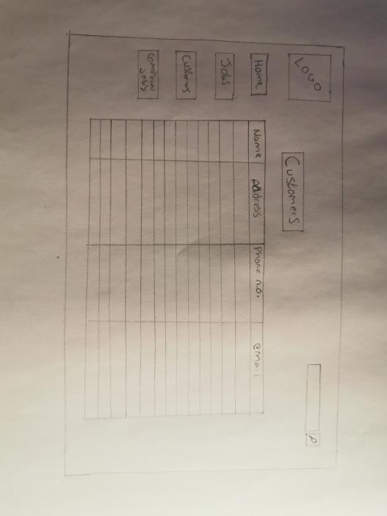

Figure First Design

As you can see this first design includes buttons to other pages on the left, a search bar in the top right and a table taking up a lot of space in the centre. But this design missing a lot of things from the requirements. The first thing its missing is a form for the user to fill out to input the data to the table this means that the user could input data straight to the table and this could cause human errors as they could accidentally input wrong data in the wrong fields. Another thing this design is missing is a way to save, load and clear the table this could cause problems as with no way to save or load the work every time the user reloads the program, they will lose all of the work they have done. Another problem with this is that then user will have no way of backing up the data.

After the first design was done a second design was done and this design was done digitally and has colour to it. But this design also has the same problems as the first one as it is also missing the same requirements. This again is due to the requirement analysis not being finished when this design was done. Even though this design doesn’t meet all the requirements it looks a lot better to the previous design as the colour makes it stand out.

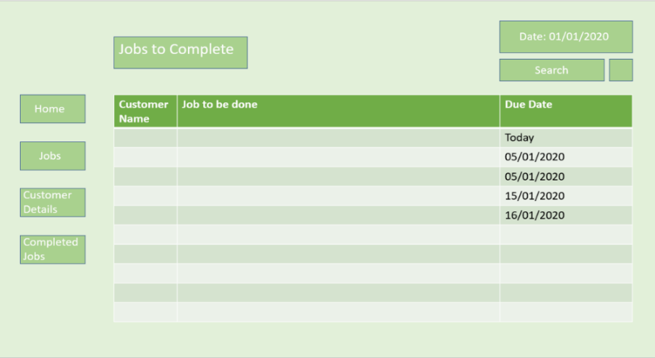

Figure Design 2

The third and final design was done after the start of the implementation and this design meets the requirements.

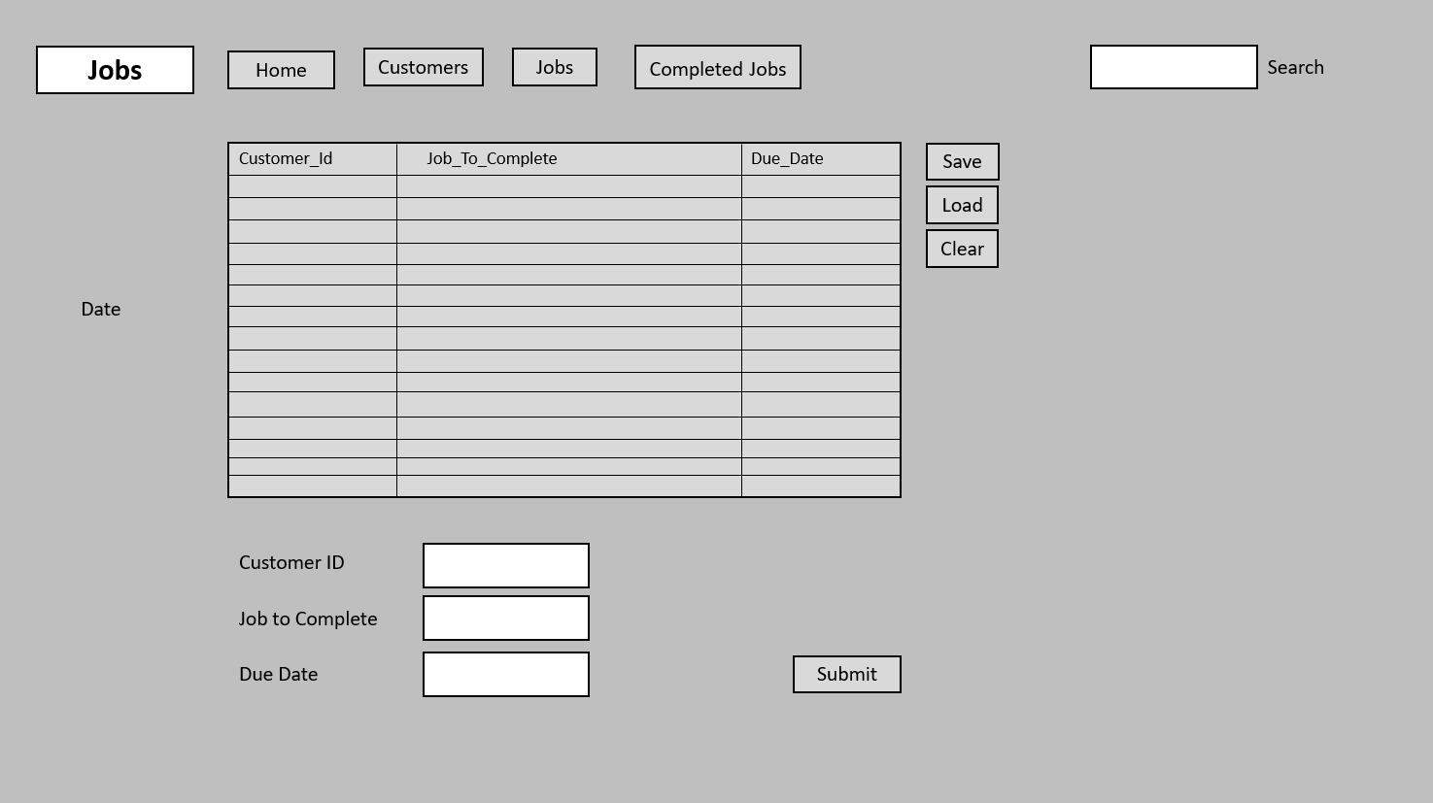

Figure Design 3

This third design makes some changes to the previous designs starting with the change of placement on the buttons which are now situated at the top of the page instead of down the side. This is because it looks better and gives more room on the rest of the page. The next thing that changed was the colour which is now grey instead of green as when implementing the program, the green tended to be too bright and made the program look unprofessional unlike the grey.

There has also been a lot added to this design starting with the form under the table. This has been added for the user to fill out to add data to the table as with this for the program can check all the data is there and is correct before adding it to the table. This will eliminate some of the human error that can occur with inputting data.

The next thing that was added to this design was the save, load and clear buttons on the right of the table. These buttons have been situated right next to the table so that they are easy to find. The save button will be programmed to save the data in the table to a txt document so when the user closes the program, they don’t lose all their work. The load button will then load the data from that txt document and input into the table exactly how it was when the data was saved. Finally, the clear button will clear the table this is there for if the user makes any mistakes.

Below in Figure 4 is a UML diagram which was made for this program. A UML diagram is a diagram based on the UML (Unified Modelling Language) with the purpose of visually representing a system along with its main classes.

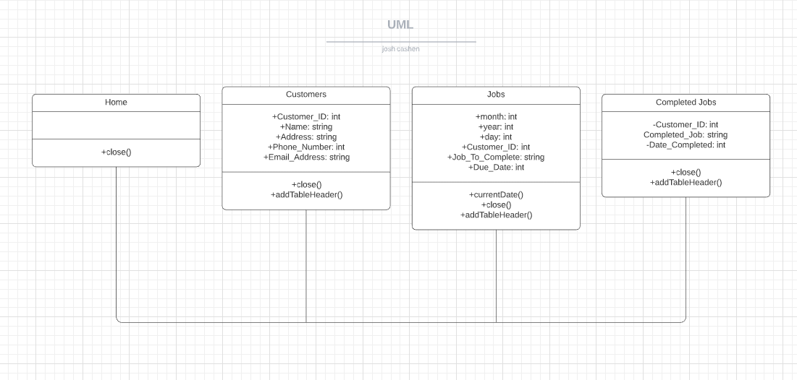

Class Name

Methods

Attributes

Figure UML Diagram

As you can see on this UML diagram the program will have 4 classes which all have a class name, Attributes and Methods. Each of these classes will be the pages of the program and each of these classes will link to each other by association.

In the top of each class is the class name and as you can see each class’ name here is name of the pages in the program which are Home, Customers, Jobs and Completed Jobs.

Below the class name is the Attributes and an Attribute is a significant piece of data Containing values that describe each instance of the class. As you can see with the Attributes it also tells you the data type and whether it is Public or Private. In this diagram – means that its private and + means its Public. The Attributes also tell you the data type for example if you look at the class Jobs it has the Attribute “+month: int” this is saying that there is a public attribute called month and its data type is integer. There are only 2 different data types used in this design these are Integer and String. An integer is a Whole number and a String is a sequence of characters.

Underneath that is the Method and a method is something that allows you to specify any behavioural feature of a class. And just like the Attributes the Methods also tells you the data type and whether its public or private, although most Methods are public.

## Chapter 5 – Implementation

The program that was made for this project was made on NetBeans which is an integrated development environment for Java. NetBeans allows applications to be developed from a set of modular software components called modules.

The first step in the implementation was to create a project in NetBeans that uses java and then create 4 jFrame Forms to be the pages of the Program and name them.

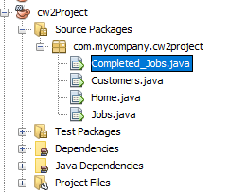

Figure Java Project

The next step was to design the different pages the program on the jFrames this was done by using the palette and dragging the options onto the Frames. The first one that was done was the home page this consisted of a panel, 4 buttons, a label and a Text area and this page looked like this.

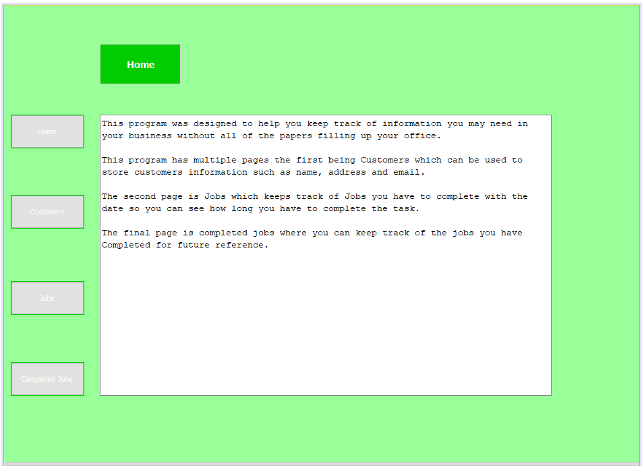

Figure First Program

After the homepage was designed it was decided it didn’t look very professional therefore the whole page layout and colour design was changed to look more professional for the business that uses it. The design that was then used was the final design from the design section.

The first thing that changed was that the page buttons where moved to the top of the page so that the page looks more professional. The other thing that changed was the colour of the page and buttons as the green was very bright.

This was the new design which used a light grey background and grey buttons which look more like it could be used in a business.

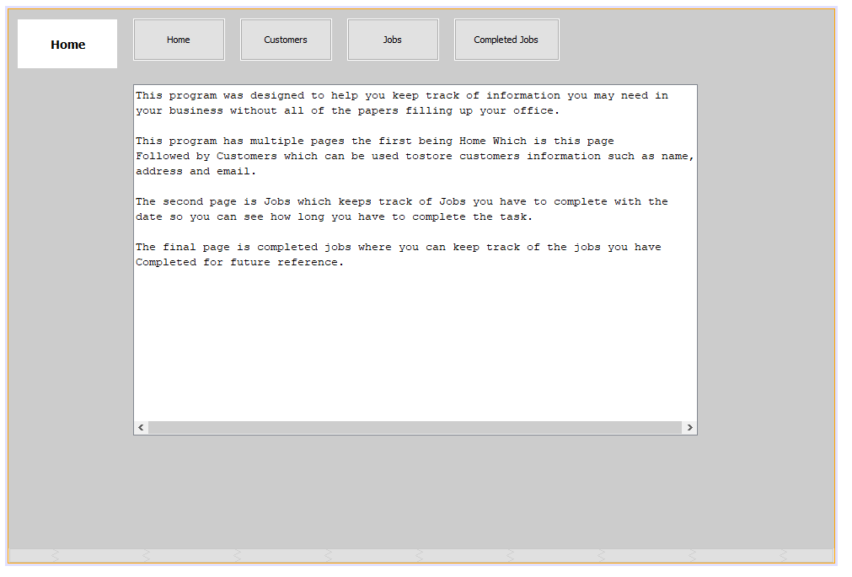

Figure Home Page New design

The second page that was designed was the Jobs page, this page like all pages consisted of the same buttons and page label at the top but this page also included a JTable for users to store data on, a form to fill that adds the data to the jTable, the current date and a search bar that can be used to search through the jTable. This is what that page looks like.

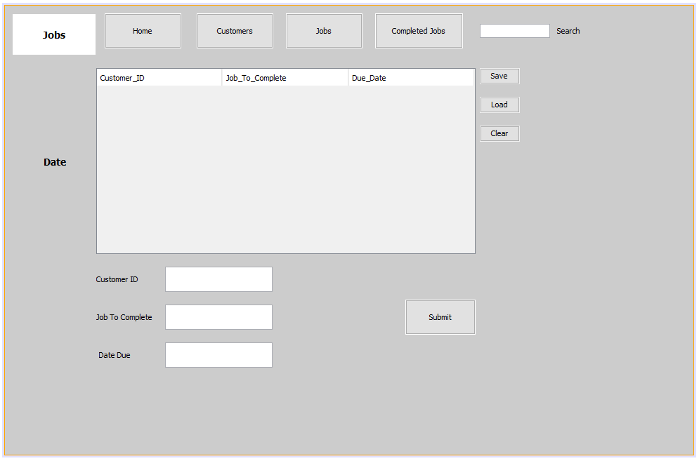

Figure Jobs Page

The other two pages look exactly like this page but have different data on the jTable and the forms to fill. These are Customers and Completed Jobs.

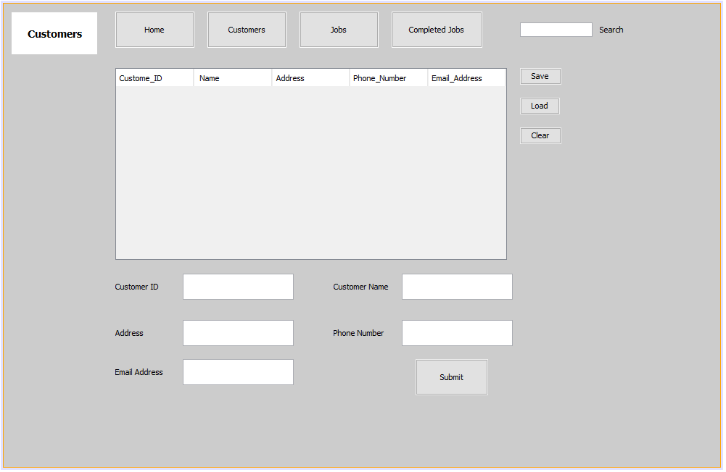

Figure Customers page

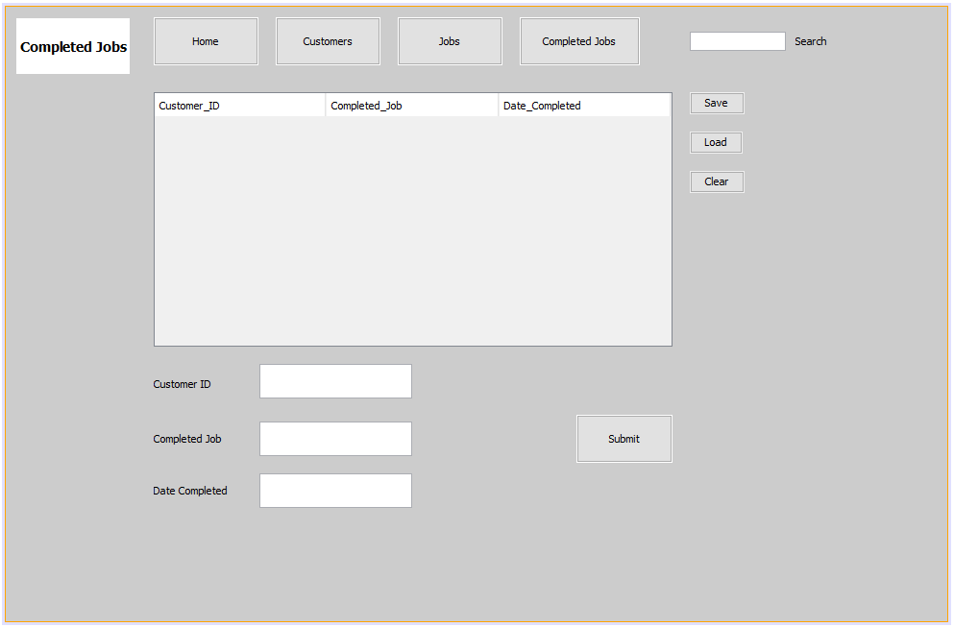

Figure Completed Jobs Page

Once all the designs where done the first thing that was coded was the buttons so the user could navigate to the different pages (Classes) this was done by using the code.

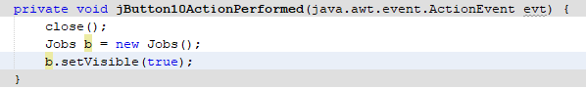

Figure Page Button Code

This code opens the Jobs page when the user clicks on the Jobs button. But when the program was running to test it was found that it opens the pages above the open page resulting in multiple windows being open. The code below was then added and when combined with the code above makes it so when a new page is opened the previous page closes.

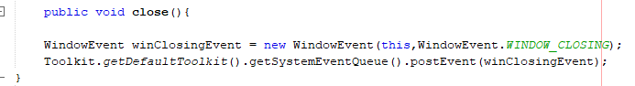

Figure Close previous page code

After the buttons where coded the next thing that was coded was the Date for the Jobs page this was done by using the following code to set the label “Date_txt” as the current Date.

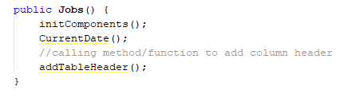

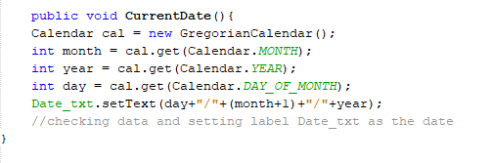

Figure Date Code

Following this was coding the forms so that when the user inputs data into the certain text boxes and clicks submit it goes onto the jTable the code used for this was.

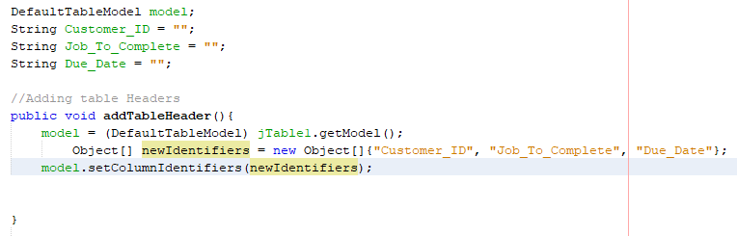

Figure Code for Forms

Followed by code on the submit button which adds the data to the table which is in Figure 15.

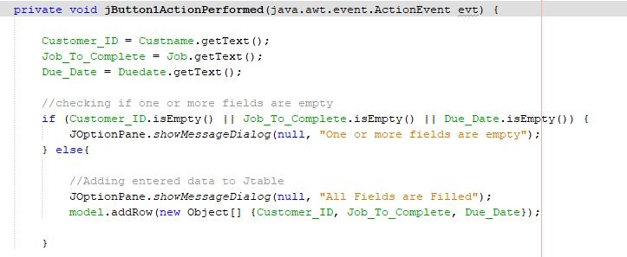

Figure Form Submit Button

This code also makes sure that there is data in all fields and produces a notice to tell the user if there is or not. After this code was added that is used to read and write to a txt document so when a user loads the program they can load the data onto the jTable and also so that when they are leaving they can save what they have added for the next time they load the program.

The code for writing onto the txt document is in figure 16. Code was also entered onto the save button so that when the user clicks save the data is stored and can be backed up.

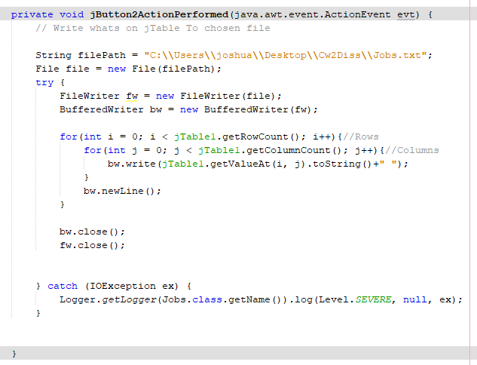

Figure Save button

And the code for reading the txt document is in figure 17, this code was entered onto the load button so that when the user clicks load the program takes what was on the txt file and re inputs it onto the jTable exactly how it was when the user saves.

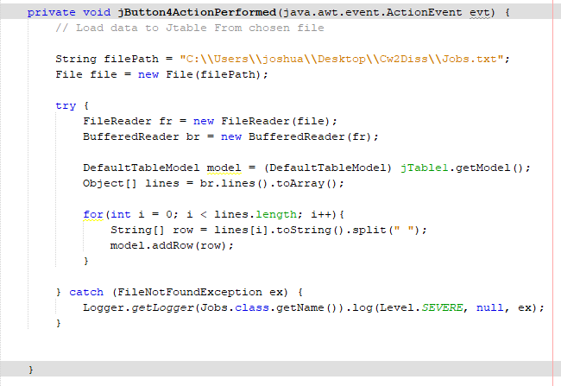

Figure Load Button

As well as reading and writing there is also a button that can be used for clearing the table this button this is to give the users a way to clear any incorrectly input data the code for this was.

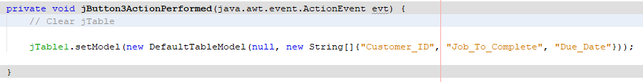

Figure Clear Button

All the buttons read, write and clear are on the right of all the jTables so they are easy to find for the users.

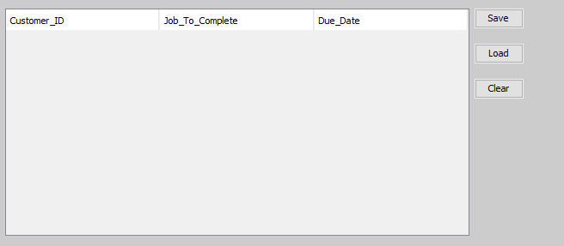

Figure Position of Clear, Save Load buttons

The last thing that was included on the implementation was a search bar on the pages with jTables that can be used to search through the jTables to find specific data such as a certain customer or Job to save time scrolling through. The code for this was.

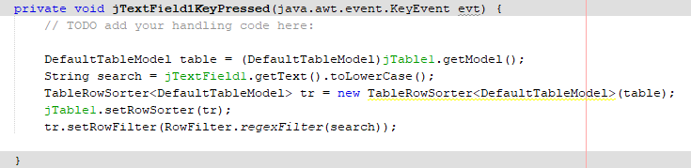

Figure Search bar code

Which searches the jTable according to what the user types in the Search bar and shows the results on the jTable.

After the program was compared to the requirement analysis it was decided to add more to the program the first thing added was a clear row button under the load and save button this for when users don’t want to delete the entire table but just a single row the code for was simple and is in Figure 21.

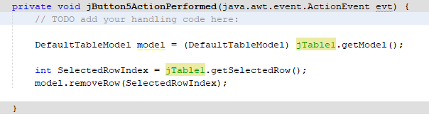 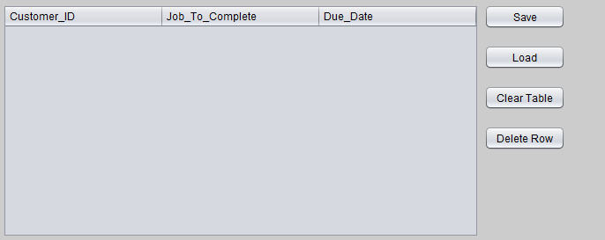

Figure Delete Row button

As well as this a way to sort the tables was also added this can be done by clicking on the header of the column that needs to be sorted, this was done so the user can sort by due date to see which jobs are due first. The code for this was.



Figure Column Sorter Code

Which again was a very simple line of code but for this project is very valuable.

## Chapter 6 – Testing

To test the program for errors a testing document was made, this document was then used to test everything on the program from page buttons to forms.

|  |  |  |  |  |  |
| --- | --- | --- | --- | --- | --- |
| Test ID | Test Description | Expected Result | Actual Result | Pass/Fail | Notes |
| 1 | Click run on the project. | The program runs and the home page loads up. | The program ran and started on the homepage. | Pass |  |
| 2 | Click on the buttons that take you to the other pages. | The other pages should load and close the page that was open beforehand. | The pages opened and closed the previous page. | Pass | The new page opens in the top left of the screen even if the previous window was moved. |
| 3 | Enter correct information on the forms on the Customers, Jobs and Completed Jobs Page and click submit | A pop up should say all fields are filled and enter the data on the corresponding jTable. | All forms worked accordingly and inputted the right data under the right heading. | Pass |  |
| 4 | Enter data into some or none of the fields on the form and click submit | A pop up should say one or more fields are empty and enter nothing onto the jTable. | A pop up appeared and no data was added to the jTables. | Pass |  |
| 5 | Enter incorrect data into a form such as letters in the phone number or date slot and click submit. | A pop up should appear saying incorrect data not allowed and it should not input the data into the jTable. | The data was inputted into the jTable with incorrect data in the fields. | Fail |  |
| 6 | Enter multiple rows of data onto the jTables and use the search bar to look for specific data. | Only data that is relevant to the search should be visible on the jTables. | It was slow but it did only show the data relevant to the search. | Pass |  |
| 7 | After data was entered onto the jTable click Save. | The data on the jTable should be saved onto a text document with the name matching the page, for example the jobs page data should be saved on a text file called Jobs.txt. | The Data was saved correctly to the right txt document in the cw2diss folder. | Pass | Might have to change in the code where the txt document is saved on other Computers. |
| 8 | After data has been saved to the txt document close the project and once re-opened click the load button next to the jTable. | The data that was saved on the file should now load onto the jTable exactly as it was saved. | The data loaded correctly into the right places on the jTable. | Pass |  |
| 9 | Whilst there is data on the jTable click the clear button on the right side of the screen. | The data that was on the jTable should be cleared so the table is empty. | The data on the table was cleared. | Pass |  |
| 10 | Click on the Jobs page and look at the Date.txt Label on the left of the jTable. | It should be showing the correct date. | The correct date was showing. | Pass |  |
| 11 | Enter Data onto the jTable on the jobs page and then click on that row after that click delete row, then test this on the other 2 pages. | The row should be deleted. | The row was deleted | Pass |  |
| 12 | Enter Data into the tables and click on one of the headers. | The column selected should become sorted. | The column clicked on was sorted. | Pass |  |

Even though all of these tests where done there are still some known problems within the program, The first being that when a user has a page open and then opens a new page no matter where the old page was the new page open in the default top right of the main monitor. This can be a problem as it could turn people away from the app due to it being a nuisance.

Another known problem with the program is that it doesn’t automatically load up what was saved onto the tables when the user clicks on the page. The reason this should have been included is so that when the user is just changing pages, they shouldn’t have to click the load button to view the data on each table as this could slow down the speed the user can work.

A large problem with the program is the Save and load button as the code for this is set to save and read a txt file on the pc it was made on, this means that when the program is opened on an external computer the code of where the file is will have to be changed to where the file is on that other computer.

## Chapter 7 – Conclusion/Critical evaluation

The aim of this project was to find the best way for small businesses to store data and to create a system based of the research. This included whether digital or paper storage was better and what kind of data should be stored on the program. After the research was done it was found that digital storage was better. And as well as this the user should be able to store data with ease. The program made for this project allows the user to store data such as Customers, Jobs and Completed jobs and it does this with a very simple interface so it easy for the user to learn how to use it. Multiple things where learnt during the coding of this project one major thing is that in java once who have set an attribute as a string you cannot simply change it to an integer this came to be a large problem in this project as it ended up making it so that users can enter letters in fields such as phone numbers.

Critical evaluation

The requirements for this project where not fully completed the first one that was not implemented was Highlighting rows on the jobs table that are close to due date. This is not on the program and therefore the user would have to look at the dates of when things are due which would take up their time. The other thing that wasn’t implemented was that the form allows you to enter letters into boxes that should really be numbers for example you could enter a name in the phone number section.

The next thing with the requirements is that it very closely follows the implementation stage this makes it look like the requirements where done after the implementation of the program. If this was done it would mess up the method used for the project which was a waterfall. This could also mean that the program is missing a lot of features that could have been in the requirements and would therefore mean the program is not as good as it could have been.

Following the requirements section was the design, this section included multiple different designs and out of the designs shown the right one was chosen. This is because out of the designs shown the final one is the one that meets the most requirements whilst also looking somewhat professional. The design section also includes a basic UML diagram that shows how the classes work with each other and what attributes and methods the classes have. This diagram looks quite basic, but this is due to there being no sub classes.

Within the implementation the right programming language was chosen this is because the program can nearly do everything it should and the reasons for the things it can’t do is because it wasn’t coded correctly, or it just hasn’t been coded in.

There were also a couple changes that occurred during the implementation the first one was to do with design, this change was where things where changed and the colour of the whole program. The newer design made the program look a lot nicer. Another change is that there were things added after the design was implemented, these where a delete row button and a way to sort rows by clicking a specific heading on the jTables. These changes were made to accommodate requirements and where therefore good changes.

The things that were done wrong in the implementation was mainly missing requirements, the first thing that was done wrong is that some of the attributes are Strings when they should be Integers this allows the user to input letters in fields such as phone number or date. This could lead to multiple human errors in the tables. The other thing that isn’t in the code is a way to make the date row show red on the jobs table when the due date is within a week of the current date. This was supposed to be included to help the user see when they are falling behind. Although this wasn’t in the implementation a way to sort the rows was added and this makes it so the user can sort by date and this will show the user what is due first.

The Project plan that was supposed to be followed was this.

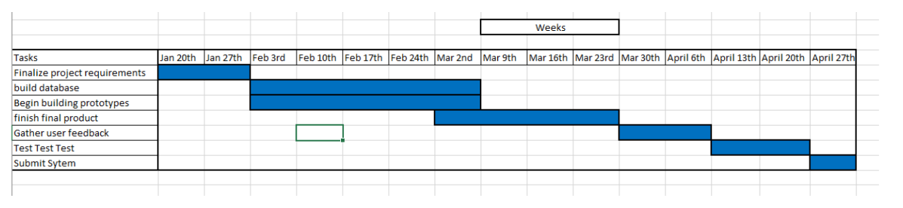

Figure 23 Project plan

But this plan was very basic and was deviated from a lot. This is because the method used was changed to a waterfall, so everything was supposed to be done step by step but even a waterfall method wasn’t followed directly. This is because firstly the design was changed after the implementation was started and if a waterfall method was being followed changes like that wouldn’t be allowed until the program was finished. Another thing that deviated from a waterfall method is that requirements where added to this was done as new things where thought of during the designing and implementing of the project. The final thing that was changed is that not everything was given as much time as the original project plan shows this was due to poor time keeping skills and starting the project later that should have started. This resulted in the project itself not being as good as it could have been if it was all started at the right date and a strict project plan was followed.

## References

Team Platinum., 2020. Paper Vs Digital Documents: Comparing Key Factors. [online] Platinum Copier Solutions | Houston, TX. Available at: <https://www.platinumcopiers.com/document-management/paper-vs-digital-documents-comparing-key-factors/>

Everything Corp. November 2015. 82 Percent of Companies Still Spending Billions on Paper Available at: <https://www.corpmagazine.com/industry/technology/82-percent-companies-still-spending-billions-paper/?__cf_chl_captcha_tk__=3879318ccb8a0106f858242731ff10a26bb93691-1589251598-0-ATOKL0Om_UK6iQM1vVf5p37sZ3bRnz2liFfolu-JV4kDN8ek9cfQxVlQYdjWC7BAaKXhSuZ6jQONDYFxFtinUVq-p_sk2fbQO8HAKIbA53iCpebtkAkDzlWYEE1PowMs9_de22fGOLOfrjkZxcAKtFKgz2nDfyByq5yPcw8Co-X3wv9x-GExgXzafUrVKQa4zN9wifLblkx-3_3O8n0AWfHXbvNSfFb7rMgjrzyS6U1nhj7ZbxqmbCDZOo62UZ2J8NsJRd94cXatdmKO8QYykXsfDI7fApa5JvmHytWLu09ACWTcD8vNYVU7NBpRokoqq9-MlO69Tv_kgSMJdYIO5qRe1uRzOZ9kvfnM7NeIpZz0lNpBKGmpIjmduc9oP7nk2TClbGUGqSpNg26QHoSOxluIys2CEp15lMx9YC66teHqRcEhsUBm2eBE6fleIj-T4D962rHN52gDeZNLXGsPjtuxzubnk5QiK5u-FNNz261cLFEBHm6Nmnp8gJjSS5FdILxNJE49FcRlUy5bfKuhxR0xC0ysxi_9sNdUa0ddupVKocbPRB8xctdonfVh12I_ji-6wyfE4G2ytniYiMy99st1_J3oAhgviYZhBHbp3iIVEeKz1q-kaAc3MKzlZmkKp8GJvLD1npra1nkXVIDWteo>

Smith, J., 2019. Why Businesses Need To Go Paperless Now. [online] ITProPortal. Available at: <https://www.itproportal.com/features/why-businesses-need-to-go-paperless-now/>

Shoen, R., n.d. Top 10 Reasons To Go Paperless | Helpsystems. [online] Helpsystems.com. Available at: <https://www.helpsystems.com/resources/articles/top-ten-reasons-go-paperless>

Datascope, 2019. 8 Disadvantages Of Paper Document Management System | Datascope. [online] DataScope. Available at: <https://mydatascope.com/blog/en/2019/11/12/8-disadvantages-of-paper-document-management-system/>

Leonard, K., 2019. Advantages & Disadvantages Of A Paperless Office. [online] Smallbusiness.chron.com. Available at: <https://smallbusiness.chron.com/advantages-amp-disadvantages-paperless-office-40653.html>

Shinder, D., 2006. 10 Things You Can Do To Protect Your Data. [online] TechRepublic. Available at: <https://www.techrepublic.com/article/10-things-you-can-do-to-protect-your-data/>

NextProcess, 2020. The Top 6 Reasons You Need To Digitize Data Storage. [online] NextProcess. Available at: <http://www.nextprocess.com/document-management/6-reasons-store-data-electronically/>

Gupton, L., n.d. The Pros And Cons Of Digital Vs. Printed Documents. [online] Staples. Available at: <https://www.staples.com/sbd/cre/tech-services/explore-tips-and-advice/tech-articles/the-pros-and-cons-of-digital-vs-printed-documents.html>

Barnett, M., 2018. Data Storage Options For Small Businesses | Data Storage And Organisation. [online] Wizbit.org. Available at: <https://wizbit.org/data-storage-options-for-small-businesses/>

Fluharty, T. and Network Access, 2016. 5 Data Storage And Backup Solutions For Small Businesses | Network Access | Pittsburgh, PA. [online] Network Access. Available at: <https://www.networkaccess.com/5-data-storage-backup-solutions-small-businesses/>

Whal, W., 2017. #4 Paper Problems And How To Solve Them | Best Office Systems. [online] Bestoffice.com.au. Available at: <https://www.bestoffice.com.au/blog/4-paper-problems-and-how-solve-them>

Singh, C., n.d. 4 Major Disadvantages Of Online Storage. [online] beginnersbook.com. Available at: <https://beginnersbook.com/2013/10/disadvantages-of-online-storage/>

Alton, L., 2017. The 7 Biggest Problems In Data Storage - And How To Overcome Them - Smartdata Collective. [online] SmartData Collective. Available at: <https://www.smartdatacollective.com/7-biggest-problems-data-storage-overcome/>

Grace, 2017. Benefits Of Paper-Based Information Management | Blog | Grace. [online] Grace. Available at: <https://www.grace.com.au/paper-based-information/>

Higher Info Group, 2019. 5 Benefits Of Storing Document Hard Copies | Higher Information Group. [online] Higher Information Group. Available at: <https://www.higherinfogroup.com/five-benefits-of-storing-document-hard-copies/>

Kefron, n.d. Hard-Copy Document Storage Services In The Digital Age. [online] Kefron. Available at: <https://www.kefron.com/blog/why-hard-copy-document-storage-services-still-have-a-place-in-the-digital-age/>

Paychex, 2015. 7 Benefits Of Going Paperless In Your Business. [online] Paychex. Available at: <https://www.paychex.com/articles/finance/benefits-of-going-paperless>

PC Dreams, 2016. Advantages And Disadvantages Of Online Digital Storage | PC Dreams. [online] PC Dreams. Available at: <https://pcdreams.com.sg/advantages-and-disadvantages-of-online-digital-storage/>

Ogl.co.uk. 2020. OGL Blog | 5 Benefits Of Keeping Digital Records | OGL Computer. [online] Available at: <https://www.ogl.co.uk/benefits-of-keeping-digital-records>

D'Arcy, K., 2017. Top Benefits Of Electronic Document Storage. [online] Blog.mesltd.ca. Available at: <https://blog.mesltd.ca/top-benefits-of-electronic-document-storage>

Xero, n.d. How To Have A Paperless Office | Xero. [online] Xero. Available at: <https://www.xero.com/uk/resources/small-business-guides/business-management/paperless-office/>

Docusign, 2020. 8 Tips For Going Paperless In Your Small Business - Docusign EMEA Blog. [online] DocuSign EMEA Blog. Available at: <https://www.docusign.co.uk/blog/8-tips-for-going-paperless-in-your-small-business/>

Kyocera, n.d. Why Being A Paperless Company Is Essential | Paperless | Kyocera. [online] Kyoceradocumentsolutions.co.uk. Available at: <https://www.kyoceradocumentsolutions.co.uk/en/smarter-workspaces/business-challenges/paperless/the-importance-of-being-a-paperless-company.html>

## Appendices



Figure First Design



Figure Design 2



Figure Design 3



Class Name

Methods

Attributes

Figure UML Diagram



Figure Java Project



Figure First Program



Figure Home Page New design



Figure Jobs Page



Figure Customers page



Figure Completed Jobs Page



Figure Page Button Code



Figure Close previous page code





Figure Date Code



Figure Code for Forms



Figure Form Submit Button



Figure Save button



Figure Load Button



Figure Clear Button



Figure Position of Clear, Save Load buttons



Figure Search bar code

 

Figure Delete Row button



Figure Column Sorter Code



Figure 23 Project plan